AutoForge – Deployment Report
A Checkpointed, Human-in-the-Loop Multi-Agent SDLC Pipeline
Research group R26-SE-033 · Faculty of Computing, SLIIT · AWS Free Tier deployment · October 2026
1. Overview
AutoForge was deployed on the AWS Free Tier in two parts. The React review interface, where reviewers start features and approve, reject or revise each stage, is hosted on AWS Amplify. The FastAPI backend, with the seven agents, the LangGraph orchestrator and the services they depend on, runs on a single Amazon EC2 instance. The interface calls the backend over HTTPS. The split was necessary because Amplify Hosting serves static web applications, while the backend needs a long-running Python process, Docker, MongoDB and local storage. Figure 1 shows the deployment and Table 1 lists where each component runs.
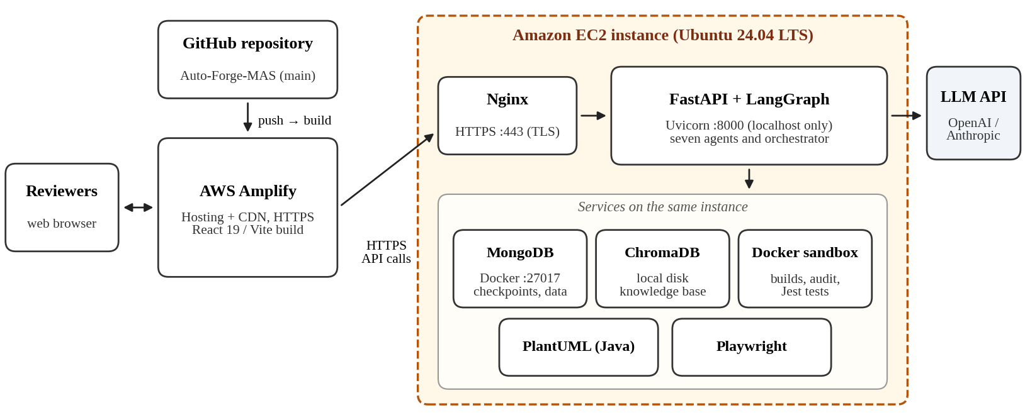
Figure 1: AutoForge deployment on AWS Amplify and Amazon EC2
Table 1: Deployed components
Component | Where it runs | Key configuration
Review interface (React 19, Vite, Tailwind CSS 4) | AWS Amplify Hosting | App root frontend; built with npm run build; dist served over HTTPS through the Amplify CDN
API, agents and orchestrator (FastAPI, LangGraph, Python 3.13) | EC2 – Uvicorn on 127.0.0.1:8000 | systemd service; API prefix /api/v1
Reverse proxy and TLS | EC2 – Nginx | HTTPS on port 443; Let's Encrypt certificate; buffering off for streamed responses
Database and LangGraph checkpoints | EC2 – MongoDB in Docker | Bound to localhost; data kept in a named Docker volume
Domain knowledge vector store | EC2 – ChromaDB on local disk | Knowledge base indexed with all-MiniLM-L6-v2
Verification sandbox (Coder, Security, QA) | EC2 – Docker | Image built from docker/coder-sandbox.Dockerfile (Node 20 with git)
Diagram and preview rendering | EC2 – PlantUML (Java), Playwright | Java runtime and Playwright Chromium installed on the host
Language model | Hosted API (OpenAI or Anthropic) | Selected through the backend's LLM provider abstraction

2. Frontend deployment on AWS Amplify
1. A new Amplify app was created from the team's GitHub repository and its main branch. Because the interface lives in a subfolder, the monorepo option was set to frontend, which also sets AMPLIFY_MONOREPO_APP_ROOT.
2. The build specification below was saved as amplify.yml at the repository root, so the build is versioned with the code.
3. The environment variable VITE_API_BASE_URL was set to the backend's HTTPS address with the /api/v1 prefix. Vite embeds this value at build time, so it was set before the first build.
4. The interface uses React Router's BrowserRouter, so a rewrite rule sends every path without a file extension to /index.html with status 200. Deep links such as a project page therefore load correctly after a refresh.
5. Every push to main now triggers an automatic build and deployment. The built interface is about 1.7 MB.
version: 1
applications:
- appRoot: frontend
frontend:
phases:
preBuild: { commands: [ "npm ci" ] }
build: { commands: [ "npm run build" ] }
artifacts: { baseDirectory: dist, files: [ "**/*" ] }
cache: { paths: [ "node_modules/**/*" ] }

3. Backend deployment on Amazon EC2
1. Instance. Ubuntu Server 24.04 LTS was launched on m7i-flex.large (2 vCPU, 8 GiB memory), one of the Free Tier-eligible types for accounts created after 15 July 2025, with a 30 GB gp3 volume and an Elastic IP address. A 4 GB swap file was added, because package installs and production builds in the sandbox are memory-intensive.
2. Network. The security group allows SSH (port 22) only from the team's IP addresses with key-pair login, and HTTP and HTTPS (ports 80 and 443) from anywhere. Ports 8000 (Uvicorn) and 27017 (MongoDB) are not exposed.
3. Software. Docker Engine, Python 3.13 with a virtual environment, a Java runtime for PlantUML, Nginx and Certbot were installed. The repository was cloned, dependencies were installed with pip install -r requirements.txt, Chromium was added with playwright install --with-deps chromium, and the sandbox image was built with Docker.
4. Database. MongoDB runs from the official image: docker run -d --name mongodb --restart unless-stopped -p 127.0.0.1:27017:27017 -v mongo-data:/data/db mongo.
5. Configuration. A server-only .env file sets APP_ENV=production, MONGODB_URI, DEFAULT_LLM_PROVIDER and the chosen provider's API key, a new random SECRET_KEY, and OAUTH_REDIRECT_BASE_URL and BACKEND_BASE_URL set to the Amplify and API addresses so that sign-in redirects work.
6. Process. Uvicorn runs as a systemd service (uvicorn app.main:app --host 127.0.0.1 --port 8000) that starts on boot and restarts on failure. Because pipeline state is checkpointed to MongoDB, a restart does not lose a paused feature.
7. Reverse proxy. Nginx forwards HTTPS traffic to Uvicorn. Buffering is turned off so that the agents' streamed NDJSON progress reaches the browser immediately, the read timeout covers long model calls (the backend's own limit is 320 s), and the upload limit matches the 20 MB knowledge-base limit. Certbot issued and renews the certificate.
location / {
proxy_pass http://127.0.0.1:8000;
proxy_http_version 1.1;
proxy_buffering off; # streamed agent progress
proxy_read_timeout 600s; # long LLM calls
client_max_body_size 20M; # knowledge-base uploads
}

4. Security measures
• Secrets (API keys, SECRET_KEY, OAuth credentials) are kept only in the server's .env file with owner-only permissions and are never committed to Git; Amplify holds only the public API address.
• Only ports 80 and 443 are public. MongoDB and Uvicorn listen on localhost and are reachable only through Nginx.
• All traffic is encrypted: Amplify serves the interface over HTTPS by default, and the API uses a Let's Encrypt certificate, which also prevents browsers from blocking the interface's calls as mixed content.
• Generated code is installed, built and tested only inside Docker sandbox containers, never directly on the host.
• The AWS root account uses multi-factor authentication, daily work is done through an IAM user, and an AWS Budgets alert warns the team before usage approaches the Free Tier credit.
• The backend currently allows requests from any origin (CORS), which suited development. For a public deployment the allowed origins should be limited to the Amplify domain.
5. Free Tier usage and running cost
Table 2: AWS Free Tier allowances relevant to this deployment
Item | Free Tier allowance | AutoForge usage
AWS account (free plan) | USD 100 credit at sign-up and up to USD 100 more; the free plan lasts 6 months | Covers the EC2 instance, its EBS volume and the public IPv4 address
Amplify Hosting | 1,000 build minutes, 5 GB storage and 15 GB data served per month for 12 months | About 1.7 MB per deployment and a few build minutes per push
Amazon EC2 | Eligible types: t3.micro, t3.small, t4g.micro, t4g.small, c7i-flex.large, m7i-flex.large | One m7i-flex.large instance
Language model | Not part of AWS | Billed by the model provider; at most about USD 0.48 per full feature run (47,900 tokens at USD 10 per million)

6. Post-deployment verification
Table 3: Checks used to accept the deployment
Check | Method | Pass criterion
Interface availability | Open the Amplify address and refresh on an inner page | Page loads over HTTPS; no 404 on deep links
API connection | Load a project list from the interface; inspect the browser console | Data returned; no CORS or mixed-content errors
Streaming | Start the Requirement Agent conversation | Agent progress appears live, not at the end
End-to-end pipeline | Take one feature through all seven stages | Each stage pauses for approval and produces a versioned artefact
Checkpoint recovery | Restart the backend service while a feature waits at a gate | The feature resumes at the same stage with earlier approvals kept
Sandbox | Run the Coder, Security and QA stages | Build, audit and Jest tests run inside Docker containers

7. Limitations and next steps
• Local model. Free Tier instances have no GPU and too little memory for qwen3-coder, the default local model, so the cloud deployment uses a hosted model API. This adds a small per-run fee and sends prompts to the provider.
• Single instance. All backend services share one instance, with no redundancy. A scheduled mongodump to Amazon S3 is the next step, so that projects and checkpoints can be restored if the instance fails.
• Build speed. Sandbox installs and production builds are slower on 2 vCPUs than on the development machines.
• Free Tier period. The free plan ends after six months or when the credit is used. The deployment would then move to a paid plan or a smaller instance type.

